https://www.pes.edu/wp-content/uploads/2019/09/pes_logo.png

**END SEMESTER ASSESSMENT (ESA) B.TECH. (CSE)**

**IV SEMESTER**

**UE18CS256 – MICROPROCESSOR AND COMPUTER ARCHITECTURE LABORATORY**

**MINI PROJECT REPORT**

**ON**

PASSWORD DOOR LOCK SECURITY SYSTEM

SUBMITTED BY

**NAME SRN**

1. **Student1 Sujay S Ambekar**
2. **Student2 Sumukh J Bharadwaj**

**JANUARY – MAY 2021**

**DEPARTMENT OF COMPUTER SCIENCE & ENGINEERING**

**RR CAMPUS,**

**BENGALURU – 560100, KARNATAKA, INDIA**

|  |  |  |
| --- | --- | --- |
| TABLE OF CONTENTS | | |
| Sl.No | TOPIC | PAGE No |
|  | ABSTRACT OF THE PROJECT | 3 |
|  | CIRCUIT DIAGRAM | 4 |
|  | ARDUINO CODE | 5 - 13 |
|  | SCREEN SHOTS OF THE OUTPUT | 14 - 15 |
|  | REFERENCES | 16 |

**ABSTRACT OF THE PROJECT:**

This project proposes the smart way to solve the common problem of the conventional door-locking system. The important problems of the ordinary door-locking systems are key lost, forgetting to lock the system and proper alarming in case of a security breach. To solve these problems, we use a method to lock-unlock the system which utilizes the Arduino and keypad for entering password. The system has a passcode based locking system that automatically locks itself after five seconds. Incorrectness in the password raises an alarm, which also creates delays and waits after successive failed attempts. This ensures protection and prevents threat to security

**CIRCUIT DIAGRAM:**

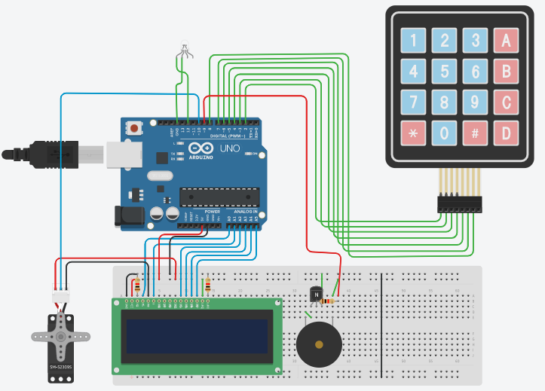

**ARDUINO CODE:**

#include <Keypad.h>

#include <LiquidCrystal.h>

#include <Servo.h>

Servo myservo;

int pos=0;

LiquidCrystal lcd(A0,A1,A2,A3,A4,A5);

const byte rows=4;

const byte cols=3;

char key[rows][cols]={

{'1','2','3'},

{'4','5','6'},

{'7','8','9'},

{'*','0','#'}

};

byte rowPins[rows]={2,3,4,5};

byte colPins[cols]={6,7,8};

Keypad keypad= Keypad(makeKeymap(key),rowPins,colPins,rows,cols);

char* password = "1234";

int currentposition = 0;

int redled = 12;

int buzz = 9;

int invalidcount = 0;

void setup()

{

displayscreen();

Serial.begin(9600);

pinMode(redled, OUTPUT);

pinMode(buzz, OUTPUT);

myservo.attach(10); //Servo attached

lcd.begin(16,2);

}

void loop()

{

if( currentposition==0)

{

displayscreen();

}

int l ;

char code=keypad.getKey();

if(code!=NO_KEY)

{

lcd.clear();

lcd.setCursor(0,0);

lcd.print("PASSWORD:");

lcd.setCursor(7,1);

lcd.print(" ");

lcd.setCursor(7,1);

for(l=0;l<=currentposition;++l)

{

lcd.print("*");

keypress();

}

if (code == password[currentposition])

{

++currentposition;

if(currentposition==4)

{

unlockdoor();

currentposition=0;

}

}

else

{

incorrect();

currentposition=0;

invalidcount++;

if(invalidcount >= 5 && invalidcount < 8)

{

++invalidcount;

failed1();

}

if(invalidcount >= 8)

{

failed2();

}

}

}

}

//FUNCTION TO OPEN THE DOOR

void unlockdoor()

{

delay(900);

lcd.setCursor(0,0);

lcd.println(" ");

lcd.setCursor(1,0);

lcd.print("Access Granted");

lcd.setCursor(4,1);

lcd.println("WELCOME!!");

lcd.setCursor(15,1);

lcd.println(" ");

lcd.setCursor(16,1);

lcd.println(" ");

lcd.setCursor(14,1);

lcd.println(" ");

lcd.setCursor(13,1);

lcd.println(" ");

unlockbuzz();

for(pos = 180; pos>=0; pos-=5) // goes from 180 degrees to 0 degrees

{

myservo.write(pos); // tell servo to go to position in variable 'pos'

delay(5); // waits 15ms for the servo to reach the position

}

delay(2000);

delay(1000);

counterbeep();

delay(1000);

for(pos = 0; pos <= 180; pos +=5) // goes from 0 degrees to 180 degrees

{ // in steps of 1 degree

myservo.write(pos); // tell servo to go to position in variable 'pos'

delay(15);

currentposition=0;

lcd.clear();

displayscreen();

}

}

//FUNCTION FOR THE WRONG CODE ENTERED

void incorrect()

{

delay(500);

lcd.clear();

lcd.setCursor(1,0);

lcd.print("CODE");

lcd.setCursor(6,0);

lcd.print("INCORRECT");

lcd.setCursor(15,1);

lcd.println(" ");

lcd.setCursor(4,1);

lcd.println("GET AWAY!!!");

lcd.setCursor(13,1);

lcd.println(" ");

Serial.println("CODE INCORRECT YOU ARE UNAUTHORIZED");

digitalWrite(redled, HIGH);

digitalWrite(buzz, HIGH);

delay(3000);

lcd.clear();

digitalWrite(redled, LOW);

digitalWrite(buzz,LOW);

displayscreen();

}

//CLEAR THE SCREEN

void clearscreen()

{

lcd.setCursor(0,0);

lcd.println(" ");

lcd.setCursor(0,1);

lcd.println(" ");

lcd.setCursor(0,2);

lcd.println(" ");

lcd.setCursor(0,3);

lcd.println(" ");

}

//KEYPRESS FUNCTION

void keypress()

{

digitalWrite(buzz, HIGH);

delay(50);

digitalWrite(buzz, LOW);

}

//DISPLAY FUNCTION

void displayscreen()

{

lcd.setCursor(0,0);

lcd.println("*ENTER THE CODE*");

lcd.setCursor(1 ,1);

lcd.println("TO _/_ (OPEN)!!");

}

//ARM SERVO

void armservo()

{

for (pos=180;pos<=180;pos+=50)

{

myservo.write(pos);

delay(5);

}

delay(5000);

for(pos=180;pos>=0;pos-=50)

{

myservo.write(pos);

}

}

//UNLOCK BUZZ

void unlockbuzz()

{

digitalWrite(buzz, HIGH);

delay(80);

digitalWrite(buzz, LOW);

delay(80);

digitalWrite(buzz, HIGH);

delay(80);

digitalWrite(buzz, LOW);

delay(200);

digitalWrite(buzz, HIGH);

delay(80);

digitalWrite(buzz, LOW);

delay(80);

digitalWrite(buzz, HIGH);

delay(80);

digitalWrite(buzz, LOW);

delay(80);

}

//COUNTER BEEP

void counterbeep()

{

delay(1200);

lcd.clear();

digitalWrite(buzz, HIGH);

lcd.setCursor(2,15);

lcd.println(" ");

lcd.setCursor(2,14);

lcd.println(" ");

lcd.setCursor(2,0);

delay(200);

lcd.println("GET IN WITHIN:::");

//1

lcd.setCursor(4,1);

lcd.print("5");

delay(200);

lcd.clear();

lcd.setCursor(2,0);

lcd.println("GET IN WITHIN:");

digitalWrite(buzz,LOW);

delay(1000);

//2

digitalWrite(buzz, HIGH);

lcd.setCursor(2,0);

lcd.println("GET IN WITHIN:");

lcd.setCursor(4,1); //2

lcd.print("4");

delay(100);

lcd.clear();

lcd.setCursor(2,0);

lcd.println("GET IN WITHIN:");

digitalWrite(buzz,LOW);

delay(1000);

//3

digitalWrite(buzz, HIGH);

lcd.setCursor(2,0);

lcd.println("GET IN WITHIN:");

lcd.setCursor(4,1); //3

lcd.print("3");

delay(100);

lcd.clear();

lcd.setCursor(2,0);

lcd.println("GET IN WITHIN:");

digitalWrite(buzz,LOW);

delay(1000);

//4

digitalWrite(buzz, HIGH);

lcd.setCursor(2,0);

lcd.println("GET IN WITHIN:");

lcd.setCursor(4,1); //4

lcd.print("2");

delay(100);

lcd.clear();

lcd.setCursor(2,0);

lcd.println("GET IN WITHIN:");

digitalWrite(buzz,LOW);

delay(1000);

//5

digitalWrite(buzz, HIGH);

lcd.setCursor(4,1);

lcd.print("1");

delay(100);

lcd.clear();

lcd.setCursor(2,0);

lcd.println("GET IN WITHIN::");

digitalWrite(buzz,LOW);

delay(1000);

digitalWrite(buzz, HIGH);

delay(40);

digitalWrite(buzz,LOW);

delay(40);

digitalWrite(buzz, HIGH);

delay(40);

digitalWrite(buzz,LOW);

delay(40);

digitalWrite(buzz, HIGH);

delay(40);

digitalWrite(buzz,LOW);

delay(40);

digitalWrite(buzz, HIGH);

delay(40);

digitalWrite(buzz,LOW);

lcd.clear();

lcd.setCursor(2,0);

lcd.print("RE-LOCKING");

delay(500);

lcd.setCursor(12,0);

lcd.print(".");

delay(500);

lcd.setCursor(13,0);

lcd.print(".");

delay(500);

lcd.setCursor(14,0);

lcd.print(".");

delay(400);

lcd.clear();

lcd.setCursor(4,0);

lcd.print("LOCKED!");

delay(440);

}

//FIVE OR MORE UNSUCCESSFUL ATTEMPTS

void failed1()

{

delay(1000);

lcd.clear();

lcd.setCursor(2,0);

lcd.print("WAIT FOR ");

lcd.setCursor(5,1);

lcd.print("15 SECONDS");

digitalWrite(buzz, HIGH);

delay(15000);

digitalWrite(buzz, LOW);

lcd.clear();

lcd.setCursor(2,0);

lcd.print("UNSUCCESSFUL");

lcd.setCursor(1,1);

lcd.print("FALIED ATTEMPT");

delay(3500);

lcd.clear();

}

//EIGHT OR MORE UNSUCCESSFUL ATTEMPTS

void failed2()

{

delay(1000);

lcd.setCursor(1,0);

lcd.print(" WAIT FOR");

lcd.setCursor(4,1);

lcd.print(" 1 MINUTE");

digitalWrite(buzz, HIGH);

delay(55000);

counterbeep();

lcd.clear();

digitalWrite(buzz, LOW);

lcd.setCursor(2,0);

lcd.print("UNSUCCESSFUL");

lcd.setCursor(1,1);

lcd.print("FAILED ATTEMPT");

delay(2500);

lcd.clear();

lcd.setCursor(2,0);

lcd.print("TRY AGAIN");

delay(1700);

lcd.clear();

}

**SCREEN SHOTS OF THE OUTPUT:**

Upon entering the correct code:

The access is granted and the servo moves to open the door

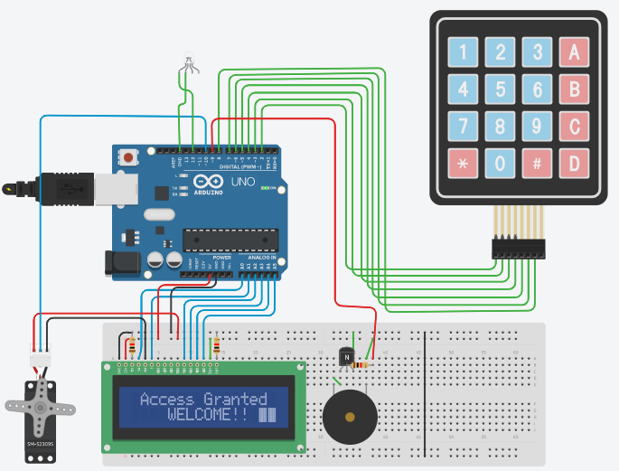

A countdown runs for a duration of 5 seconds, the time during which the servo remains in the open position. Then relocking happens and the servo returns to its original position

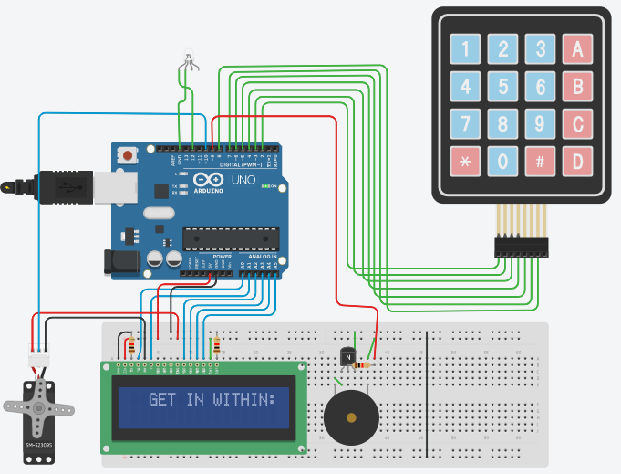

Upon wrong input, piezo emits a beeping sound with the led flashing red alarm light

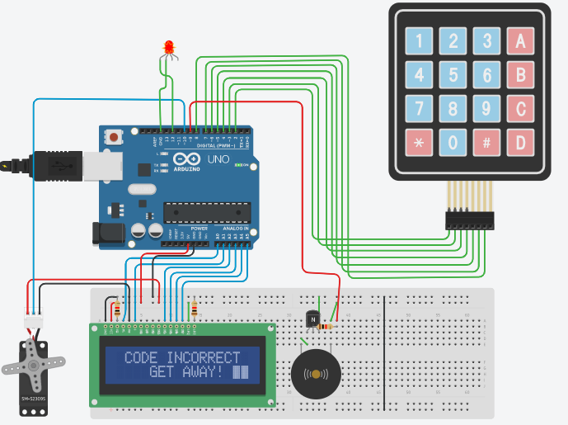

Upon successive wrong inputs, delays are created with continuous beeping sound

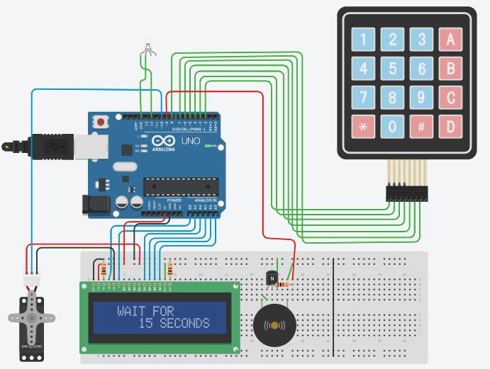

**REFERENCES**

**RGB led lights sample tinkercad project for alarm system**

**https://www.instructables.com/RGB-LED-Color-Mixing-With-Arduino-in-Tinkercad/**

**How to use the keypad:**

**https://www.instructables.com/Using-44-Keypad-With-Arduino/**